Chinese Social Media Competition 2019
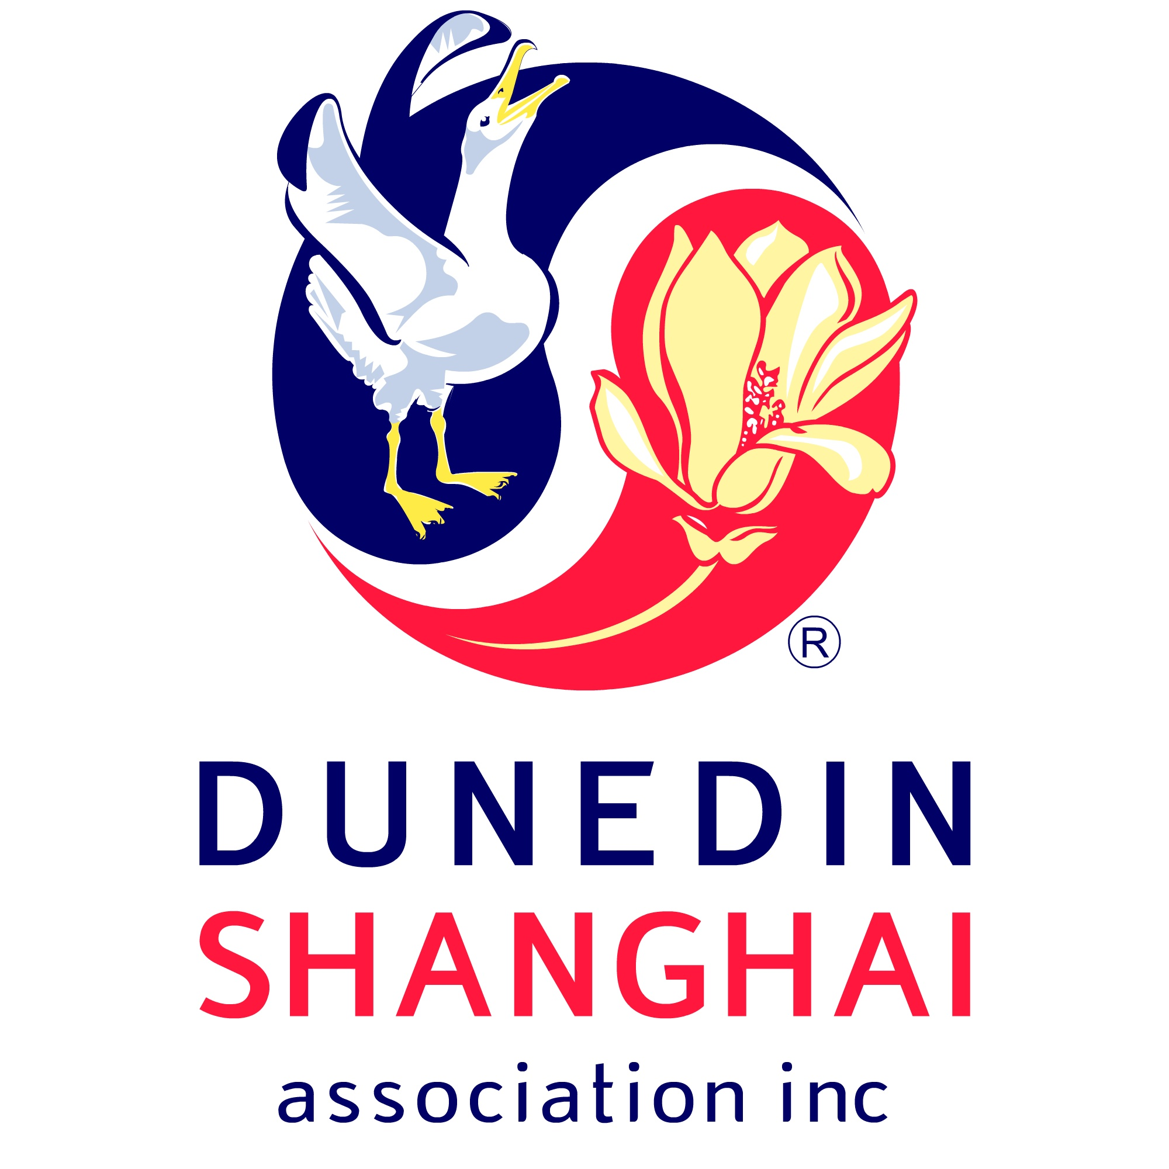
Entry Form

Team Name:
Business or tourist attraction involved:
Consent of business or tourist attraction attached: |  | Yes/No
Team Member(s): | Name: | Email: | Phone: | Residential Address: | If student, which Institution and course are you studying?
Which of the above team member is the Team Leader/main contact?
What was your budget for the whole event/campaign? Show breakdown |  | (Please use extra sheets if there is insufficient space.)

Which Chinese Social Media Platform have you used and how have you promoted your campaign on the platform? (Note: If any social media account was used other than one belonging to a team member, then consent of the account holder must be obtained and provided as part of this entry.) |  | (Please use extra sheets if there is insufficient space.)
Set out your entry:  - What was your event/your production?  - What was involved in your event/production?  - Was that a one-off event/  production or was it be a series? If the latter, what frequency? Over what period?  -What format was the content for the social media be in- e.g. written, pictures and/or video? Describe.  Please provide a link or copy of your video and related content which you posted. | (Please use extra sheets if there is insufficient space. You are free to provide further information by whatever format, e.g. written material, video or photos)

Was any regulatory consent required for your event/production/campaign to be run? If so, please specify what they are and attach the consents obtained. | (Please use extra sheets if there is insufficient space.)
How did you measure the impact of your campaign? Please provide all information and evidence showing the campaign. | (Please use extra sheets if there is insufficient space.)
How did your campaign promote Dunedin as a tourist destination? | (Please use extra sheets if there is insufficient space.)
As entrants to this competition, I/we agree to the Rules and Details of the Competition as published on the Dunedin Shanghai Association website. If required, we will provide to the judges of this competition (in English and in Chinese) full evidence of the impact of the Chinese social media campaign and any other relevant information for competition purposes. If required, we will provide relevant access to any account or data to enable the information to be verified.  We agree for our entry including all videos and material to be publicised in social and general media. We also agree to make ourselves available for interviews by the media to promote this competition. | (To be signed by all members of the Team as entrants to this competition. Please use extra sheets if there is insufficient space. )  Name Name Name  Signed Signed Signed  Name Name Name  Signed Signed Signed
Entries close 15 November 2019. Please send entries to dunedin@terramark.co.nz
Enquiries to: Teresa Chan - The Dunedin Shanghai Association, C/- Teresa Chan Law Limited
Ph (03) 477 1069 E teresa@tchanlaw.co.nz
All enquiries regarding Chinese social media to: Jasmine Chu jasmine.chu@otago.ac.nz

