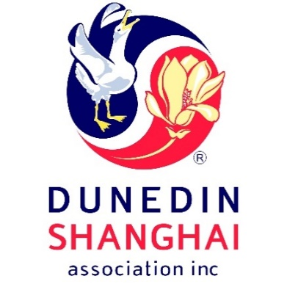

*Fancy organising an event like the Jaffa Race down Baldwin Street? Or the Rubber Duck Race down the Leith?*

*What about rewrite part of a Chinese TV historical drama and set that in the historical buildings in Dunedin?*

*Or play a real life game of Cluedo with Chinese characters in Larnach’s Castle?*

*Or set up a race of competitors dressed up as Yellow-eyed penguins surfing down the sand dunes at Sandfly Bay?*

*Or write a current Chinese story set in Dunedin?*

Then produce an interesting video and launch it on Chinese social media platforms

to promote Dunedin as a tourist destination?

**This competition may be of interest. Details of the competition are on**

[**www.dunedinshanghai.com**](http://www.dunedinshanghai.com)

under NEWS

**Prize: The first prize is $1,500, second prize $1,000, and third prize $500.**

**The top 3-5 entries will be publicised in social and general media**

**e.g. Otago Daily Times, Channel 39, TVNZ, and Chinese social media.**



**Entries close on 15 November 2019**

All entries to be submitted in the **attached** Entry Form to [**dunedin@terramark.co.nz**](mailto:Dunedin@terramark.co.nz)

Competition supported by DCC, the University of Otago and the Otago Polytechnic.

**Chinese Social Media Competition**

**Promoting Dunedin as a Tourist Destination to Chinese Tourists**

**Official Sponsor**